COUNTY RECEIVING AND DISTRIBUTION POINT INFORMATION | - County Name  Bertie (Area 1 ) |  | - Name of Facility  Primary Receiving Point:  Bertie County Water Maintenance Facility (old County Farm area) | - Date  September 6, 2001
4. Directions to Facility (Attach Strip Map)
Driving Directions:
From Williamston , Raleigh, and other points west, enter Bertie County on US 13/17. Travel north to Windsor city limits; see NC National Guard Armory on right (east side of highway). Turn right on County Farm Road, travel approximately ¾ mile, past sewage treatment plant. See Water Maintenance / Receiving Point facility on left.

From Ahoskie, Points North : Enter Bertie County and Windsor on US 13. Travel South on US13 Bypass around Windsor; see National Guard Armory on left; turn left onto County Farm Road, as stated above.

Physical Address of Facility: 207 County Farm Road
5. Sketch Layout of Facility
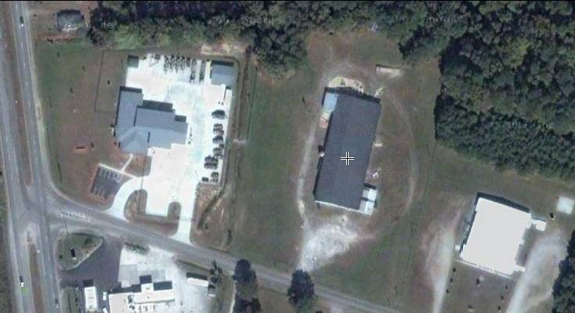

Include Roads, Driveways, Other Buildings, Landing Zones, Etc.
6. Facility Information
Is this the Primary County RDP? YES Does this facility have a Landing Zone? Yes , adjacent

Does this facility have Loading Docks? YES If so, What is the Latitude and Longitude?_35degrees –58.674 N
76degrees-56.759 W

If so, What size is the Landing Zone? _200 x 200 each
7. Contact Information AT THE CRDP

Point of Contact: Rickey Freeman, EM Coordinator
252-794-5302 EM Office Alternate Point of Contact: Bertie Water Dept. 252-794-5350
800-979-7570 pager

Facility Phone Number: 252-794-4427 Alternate Phone Number: N/A

Fax Number: N/A Alternate Fax Number: EOC 252-794-5361

VERIFIED by: Rickey Freeman, Bertie EM Coordinator DATE: September 6, 2001 |  | Phone Number: 252-794-5302 office in Windsor, NC

